Outlook Work Allocation Tool

Contents
Outlook Work Allocation Tool 1
About the tool 2
Tool Features 2
Benefits 6
System Requirements 6
Limitations 6
How to use this tool 7

About the tool

Outlook Work Allocation Tool is an Excel and Outlook based VBA tool which helps to allocate and manage work received through emails. The tool can be saved in a common place in SharePoint/OneDrive where multiple users can open the tool at the same time. Tool has inbuild dashboard and configurations to manage it effectively.
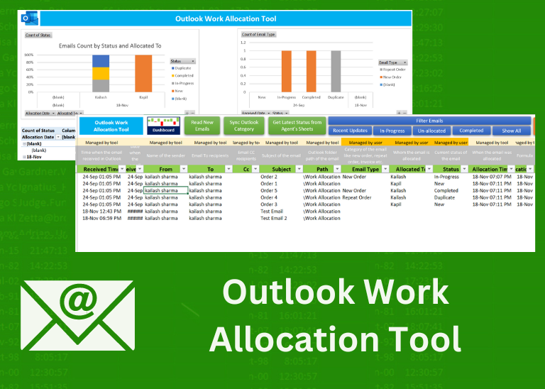

Tool Features

Multiple Configurations: Configure the tool and use it as per your requirements. Configurations available for Outlook Folder, Sub-Folders, Older Emails, Email Categorization, Admin password, Email Types, Status and User Management.
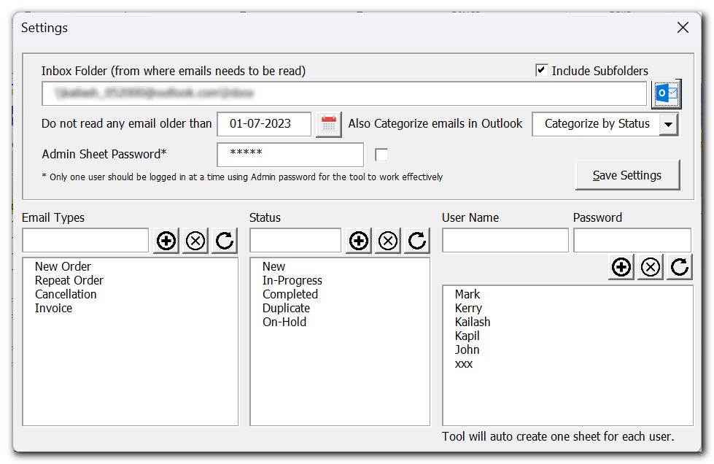

Login Enabled: All users and required to login into the tool to access their respective sheets. This helps to control modifying other user’s data.
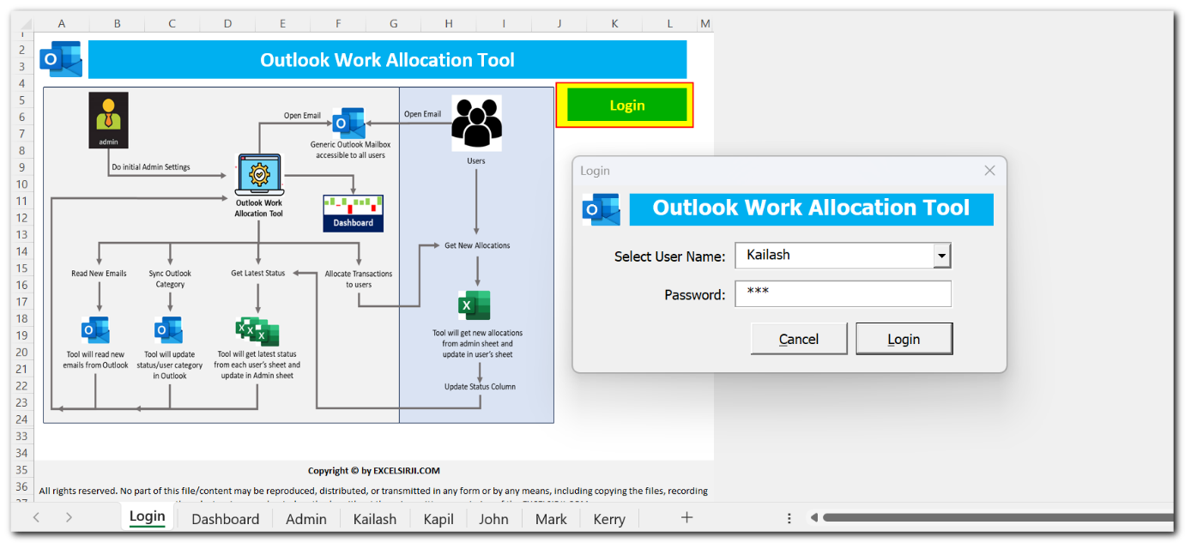

Outlook Integration: Tool has capability to read emails from Outlook and list them in Admin sheet for allocation. You can also use optional feature to sync transaction status or allocated to details in Outlook email category.
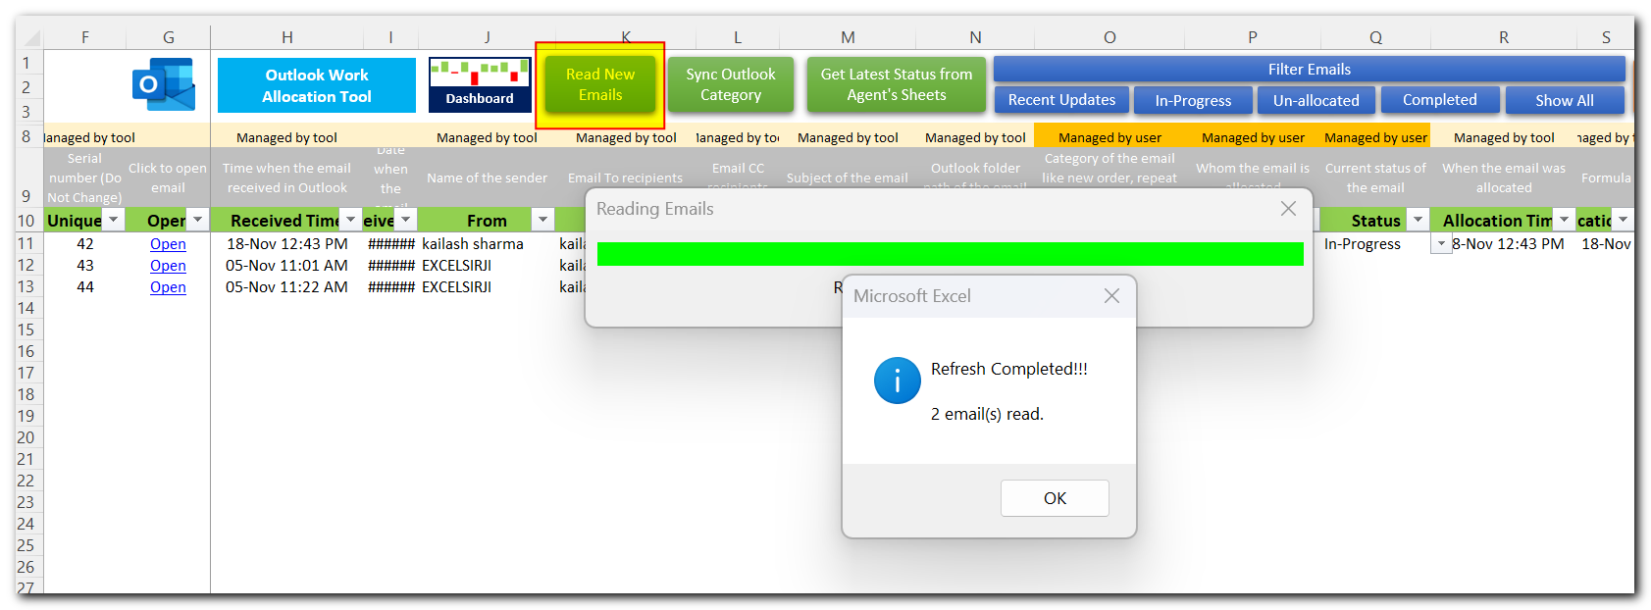
Easily Allocate and Get Latest Status: Allocate emails directly from excel sheet. To get latest status, simply click on a button.
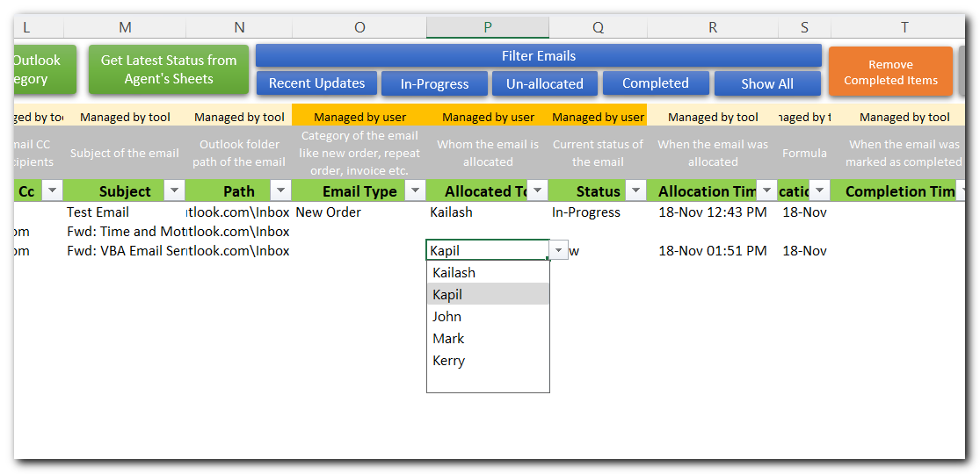
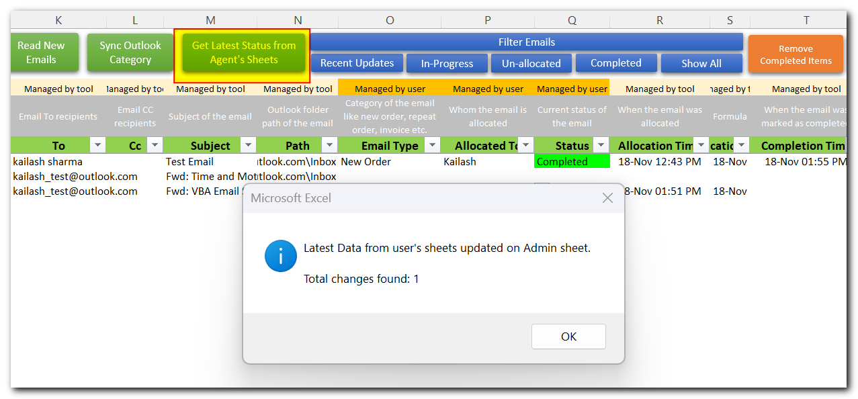
Filter Emails: Use the pre-defined filters to easily identify recent updates, In-Progress, Un-allocated or Completed Cases
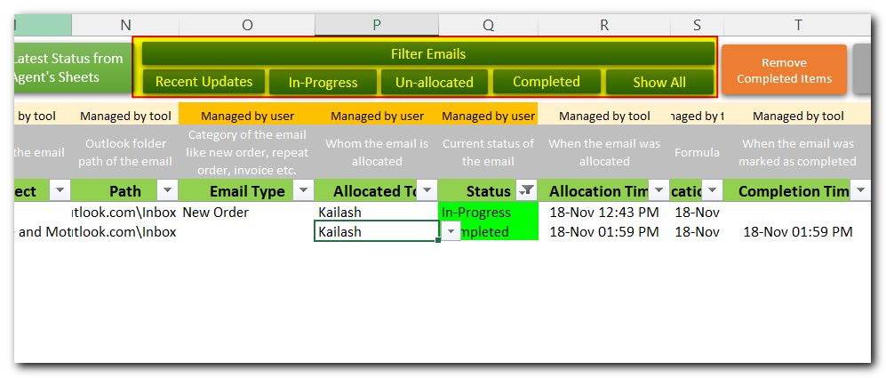
Archive Older Items: Get rid of older items by archiving them to new file and remove from admin sheet.
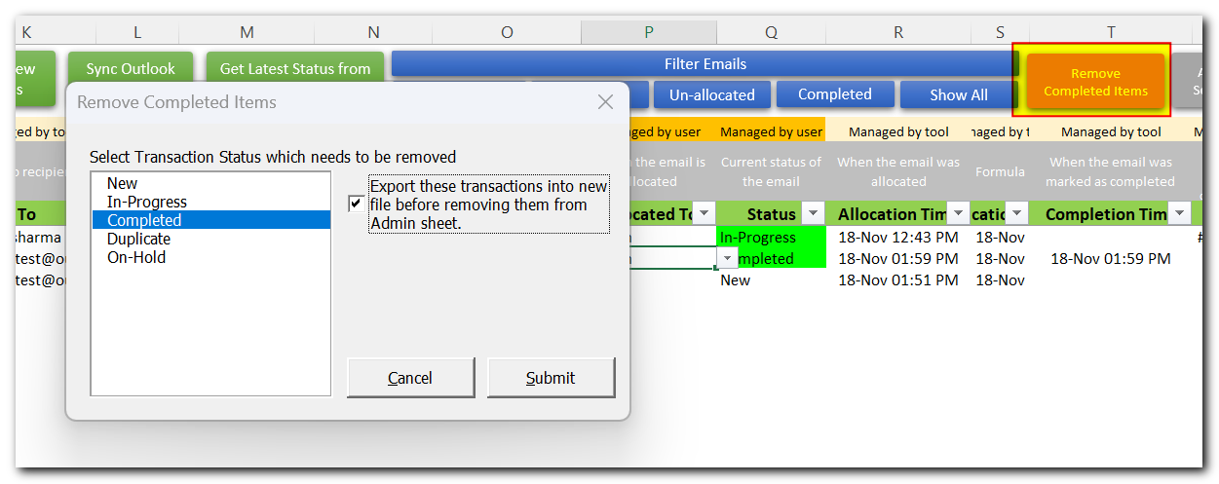

Monitor progress through interactive dashboard: You can monitor progress using pre-defined charts and pivot tables.
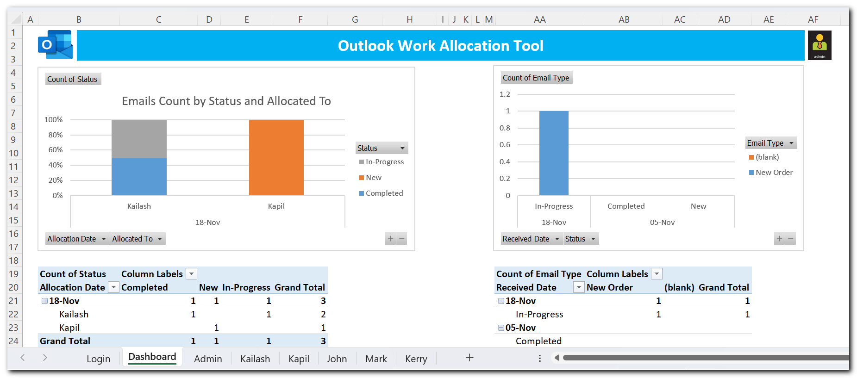

Benefits
- Easily and efficiently manage work received through emails.
- Get real time processing status along with status history and time taken to process an email.
- Saves huge amount of time, avoid un-necessary email conversations, consolidation, reporting and monitoring by using centralized tool in place.

System Requirements
- Installed version of MS Excel 2016 or above version
- Installed version of MS Outlook 2016 or above version
- Windows 7 or above operating system

Limitations
- As the number of records / emails are increased, tool may take more time to complete the task. It is suggested to archive/remove old records to maintain the performance.
- We have tested this tool with 10 users. While tool is compatible to work with more user; however, tool performance might be impacted.
- It is expected all users have access to the mailbox from which email are being read; else users will not be able to open the email from their system.

How to use this tool
- You will be receiving your tool copy in zip format.
- Once received, unzip the file, and place it in a SharePoint, OneDrive, Teams or any other shared path where all users can access and open the file at the same time.
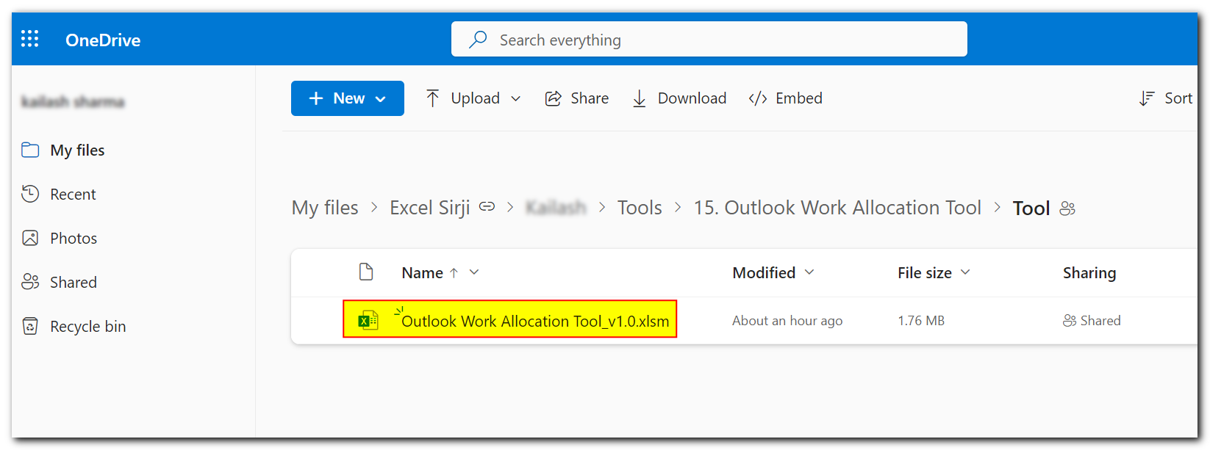
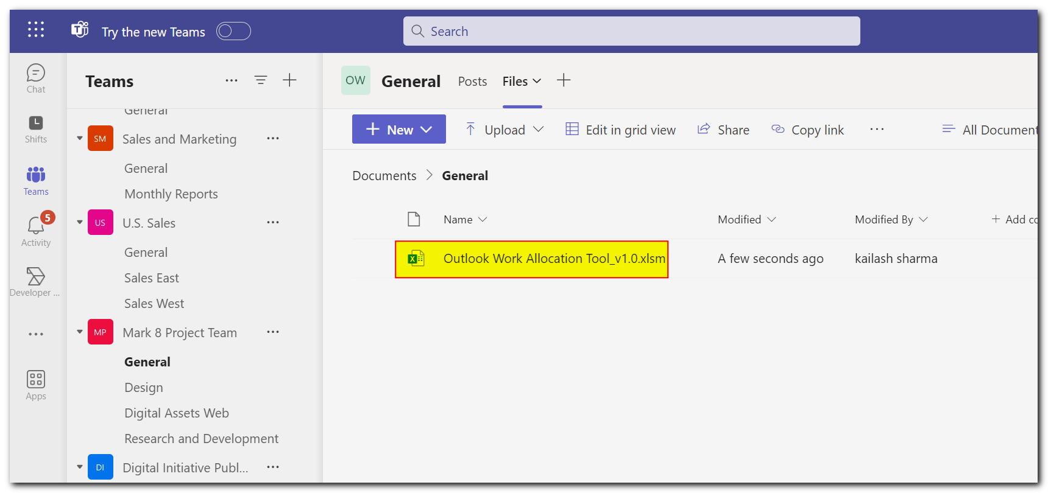
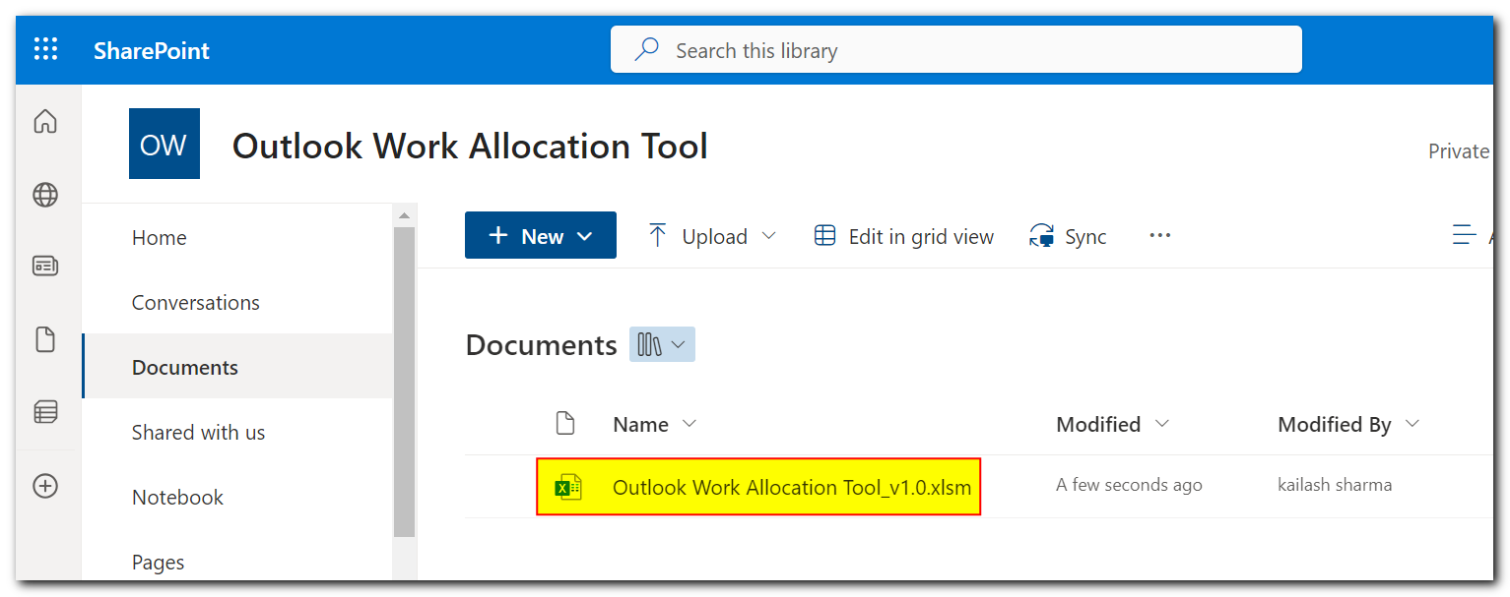

- Open the tool, you will see login sheet. This sheet also contains the process map of how the tool works.
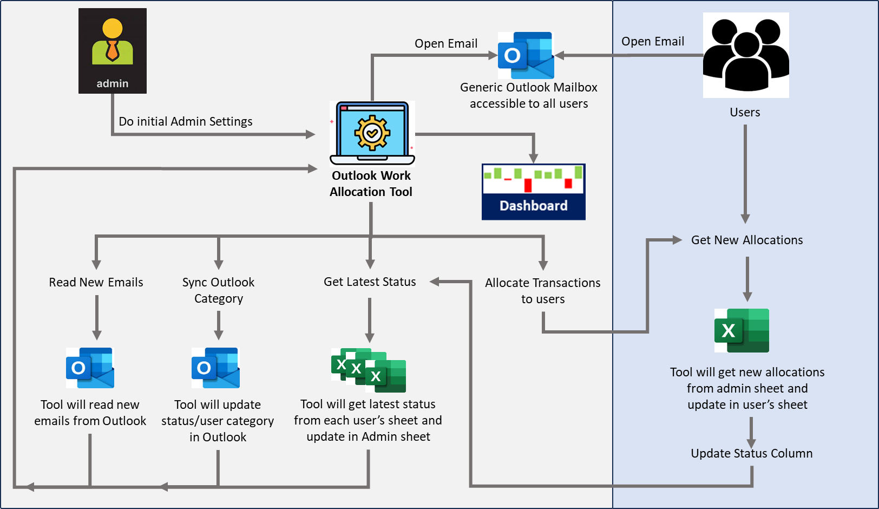
- If you see a yellow bar mentioning macros have been disabled, then click on Enable Content.
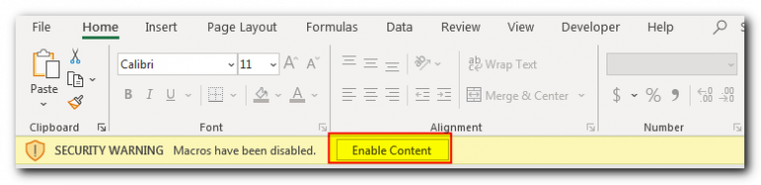

- Use Login button to login using Admin user name. For first time password, refer read me file which much have come in the zip folder.
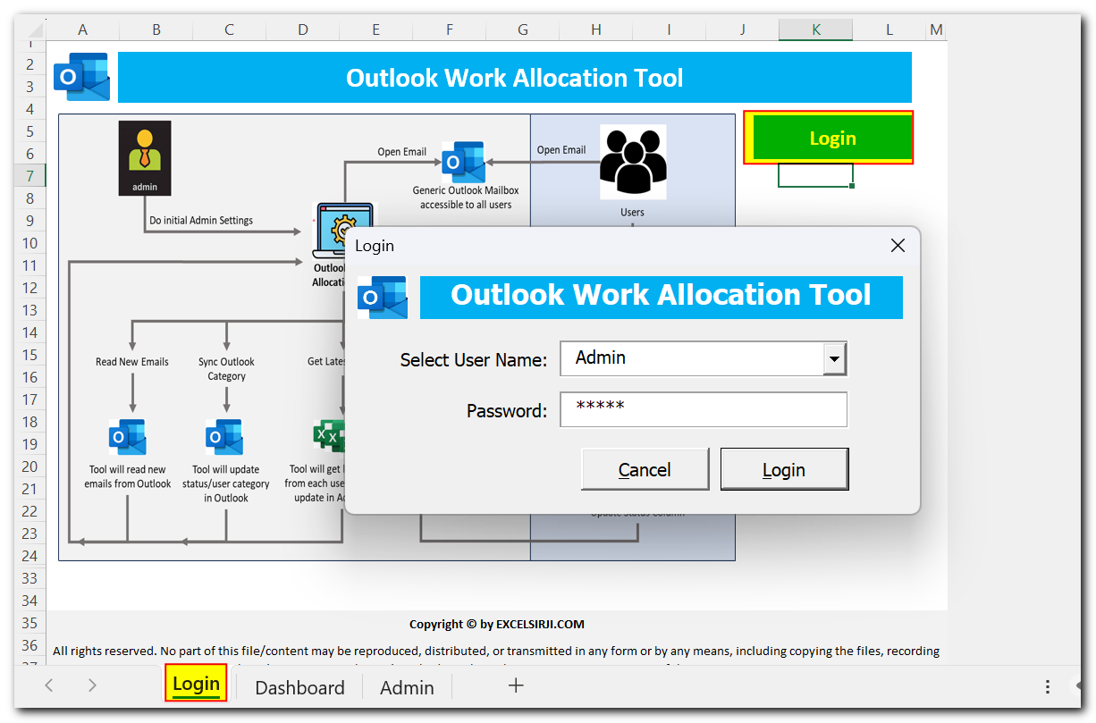
- Once you logged in using Admin id, first thing needs to be done is admin settings. Click on ‘Admin Settings’ button on Admin sheet for the same.
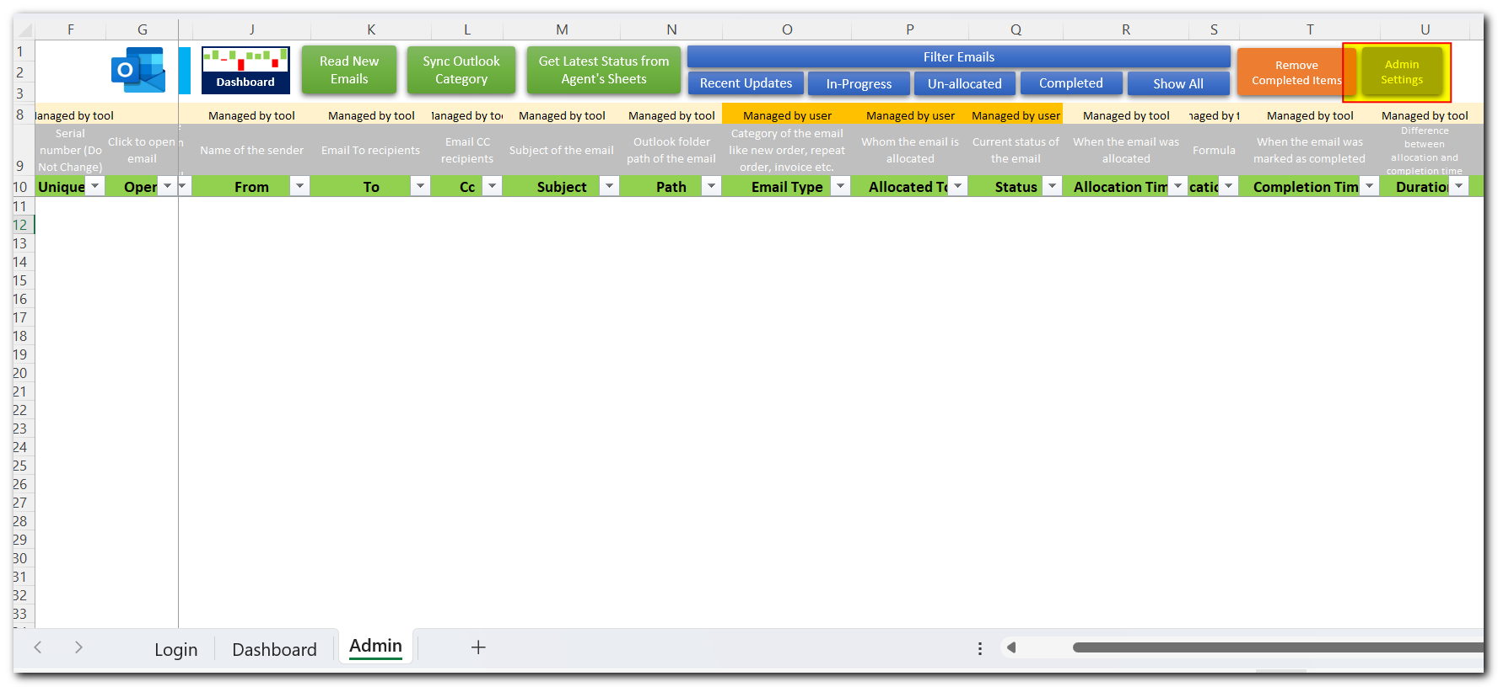

- Let’s understand Admin settings.
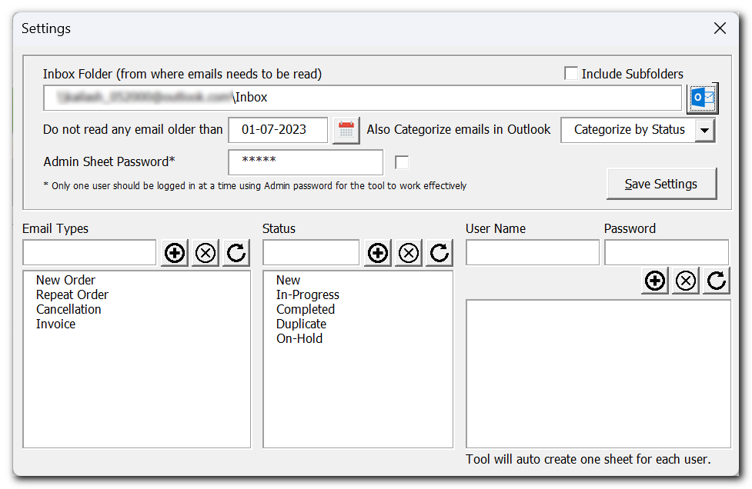
Inbox Folder: You can map any folder from Outlook where you receive work/transaction emails. If the Outlook folder has subfolders as well where new emails are received, then ensure to tick ‘Include Subfolders’ checkbox. It is preferred to use shared mailbox so that other users can also access the emails using the tool.
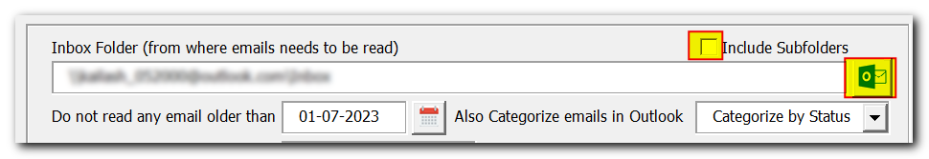
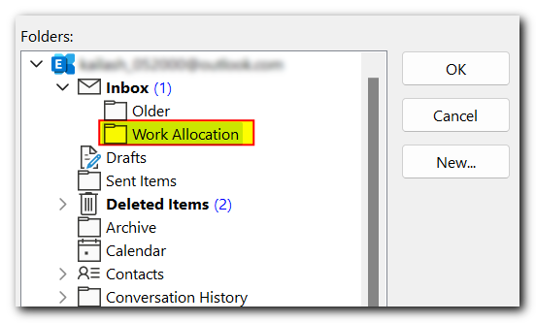

Older Emails: Tool has feature for excluding older emails while looking for new email. This helps when the Outlook folder you selected already have many emails which you do not want the tool to pick.
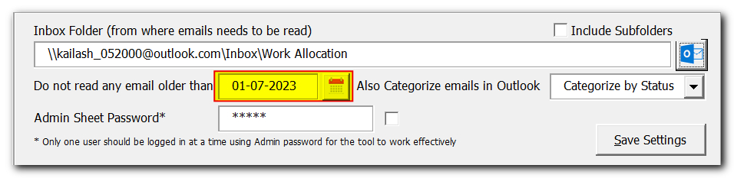
Categorize Email: This is an optional feature if you also want to categorize the emails by Status or Users in Outlook.
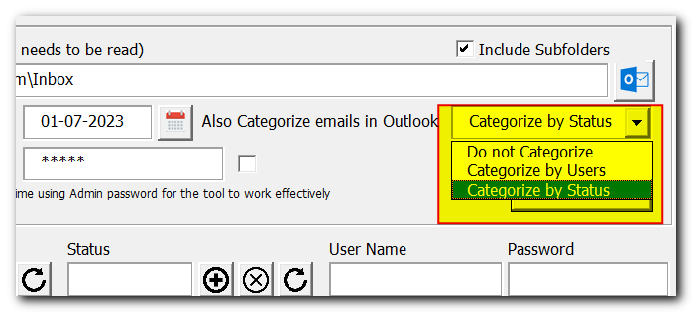
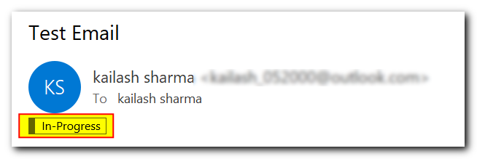

Admin Sheet Password: This is the password used to login using Admin user name.
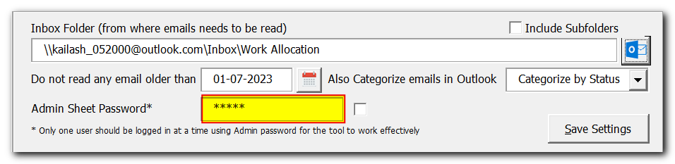
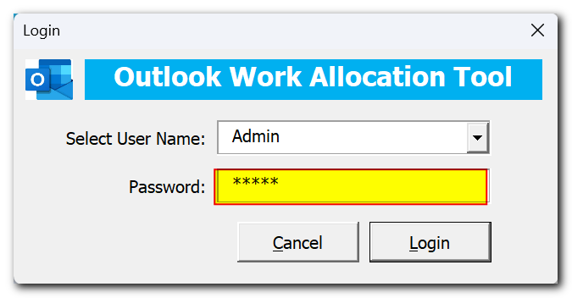
Email Types, Status Settings: Use these settings to control the dropdown appears on the sheet.
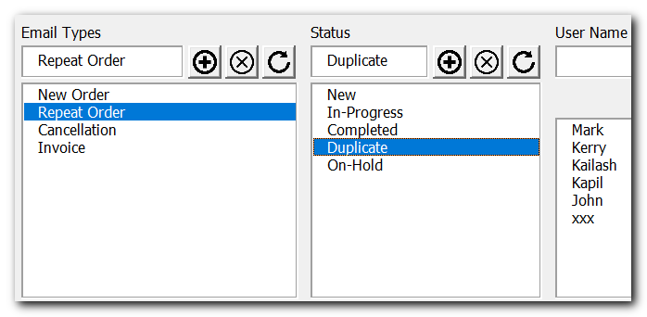
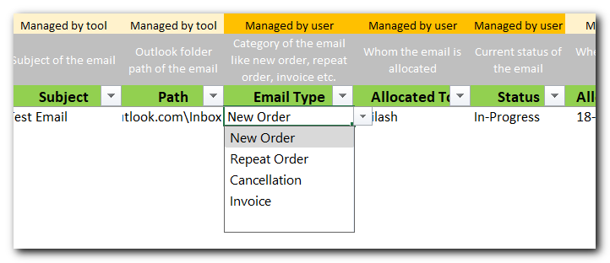

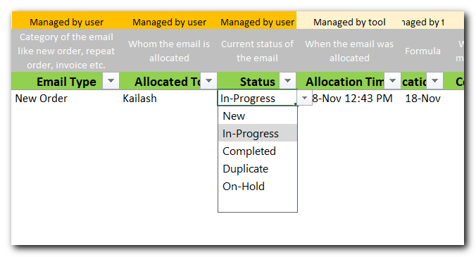
User Management: Use this section to add remove users from the tool. Note that for each user a new sheet with the user name will be created. You can set user’s password so that users will not be able to modify data other than their respective sheet.
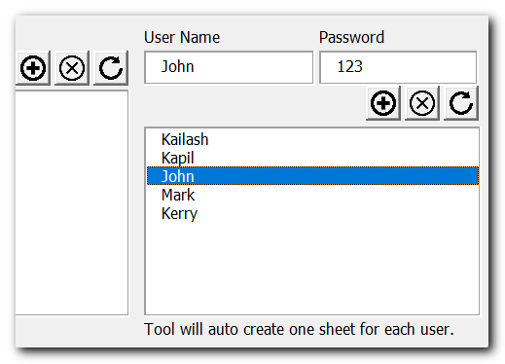
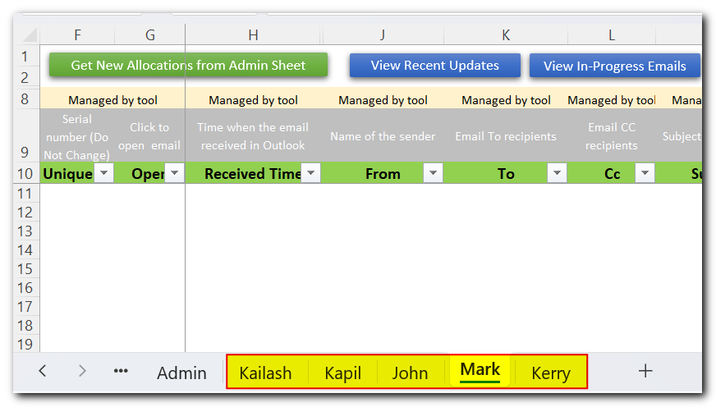
- Once the Admin settings are completed, we are ready to read emails from Outlook. Let’s click on ‘Read New Emails’ button for it.
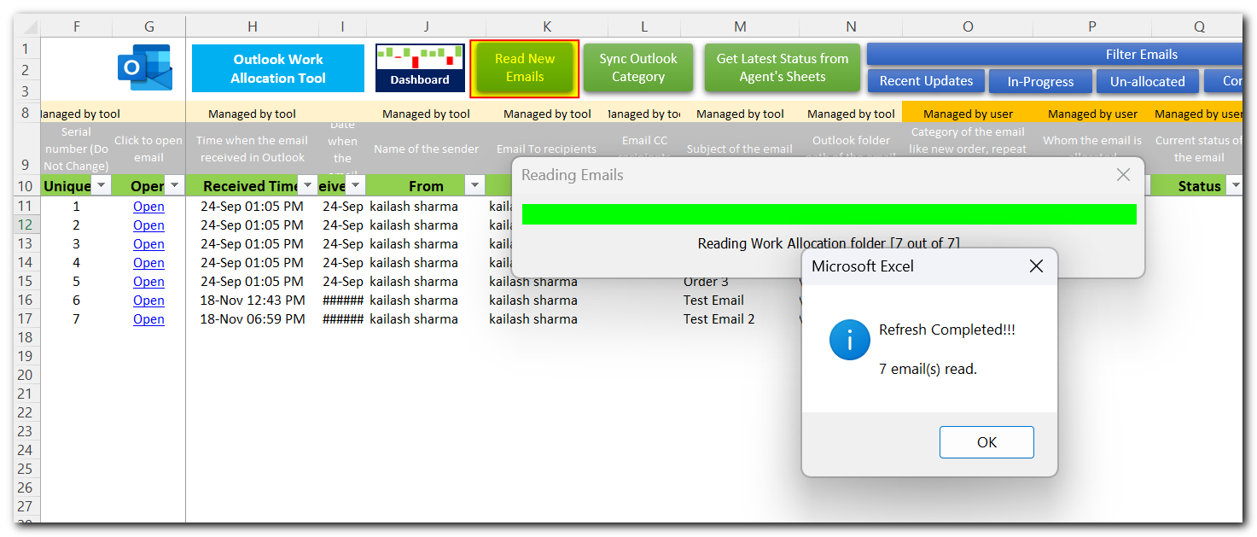
- Next step is to allocate emails to users, for that use Allocated To column as shown below. You will notice that as-soon-as you allocate any email to a user, Allocation Time and Status are automatically filled.
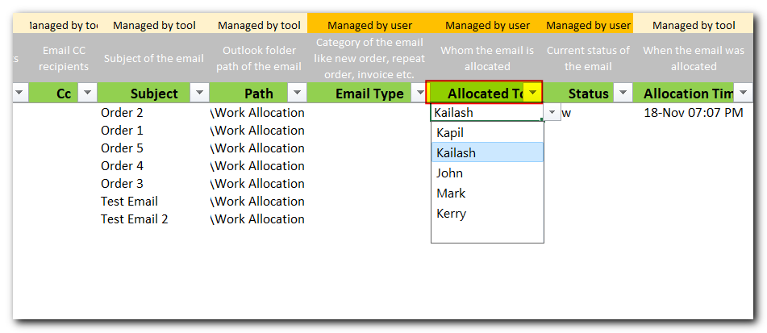

- Now let’s see how a user works on allocated cases. For that let’s login using one of the user.
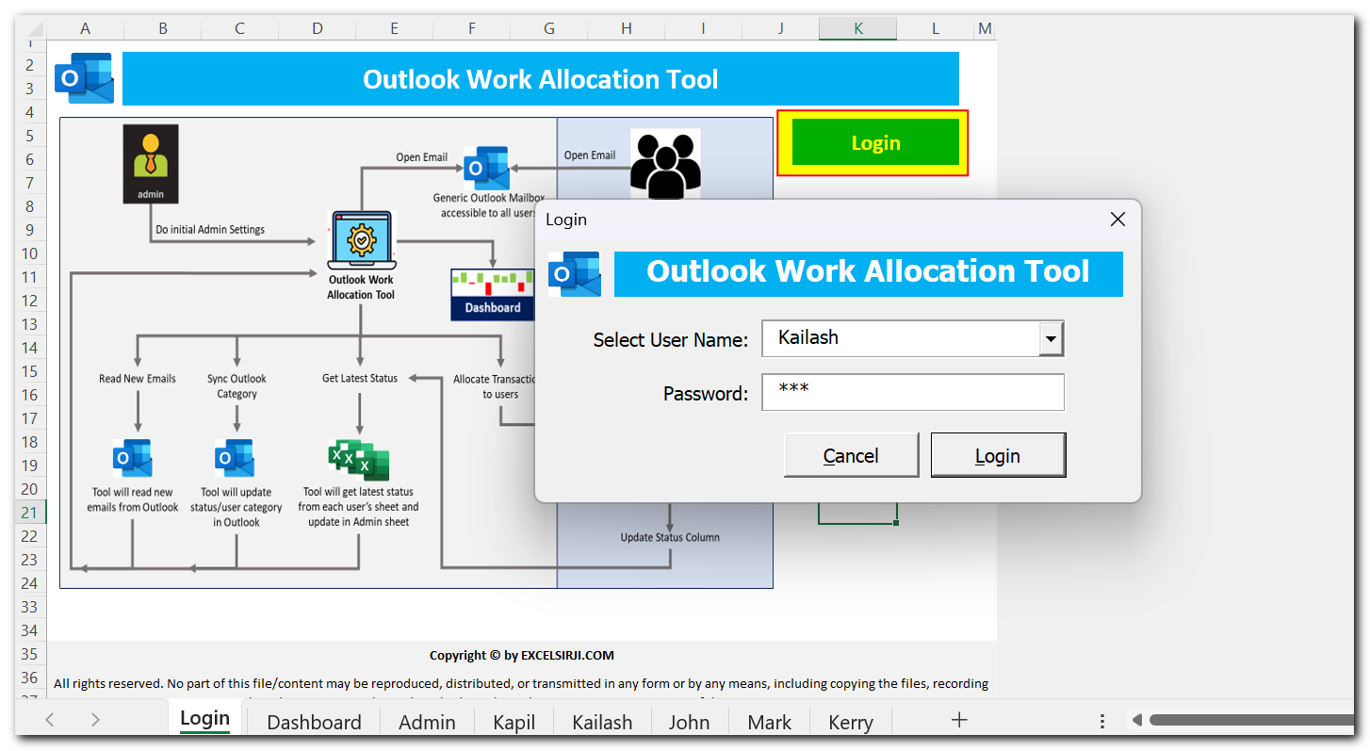
- To view newly allocated emails, let’s click on ‘Get New Allocations from Admin Sheet’
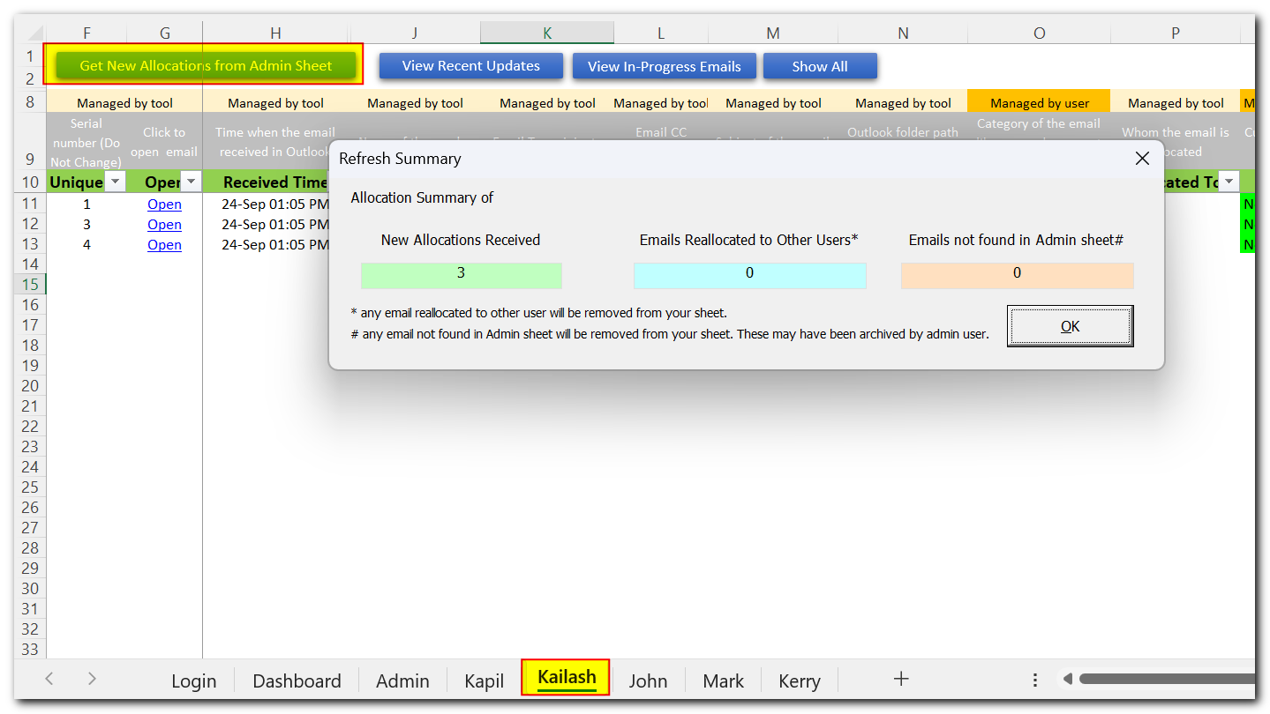

- User can work on the case assigned and use ‘Open’ link to open respective email. Note that user must have access to the same mailbox and it should be available in Outlook application for the email to be opened.
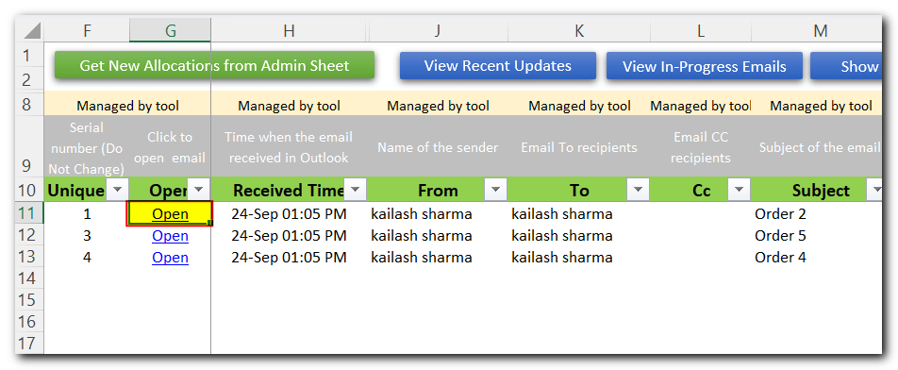
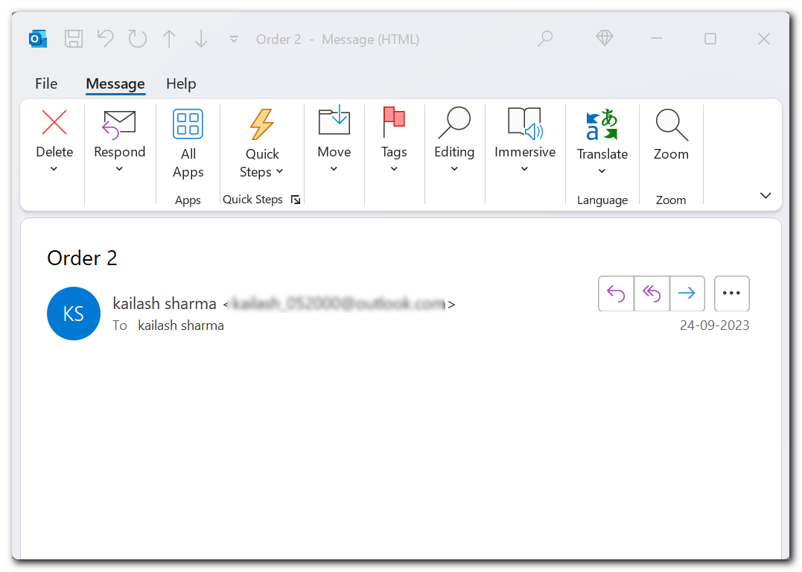

- As the case progresses, Users can update current status of the case in ‘Status’ column and few more columns like ‘Email Type’ and ‘User Remarks’
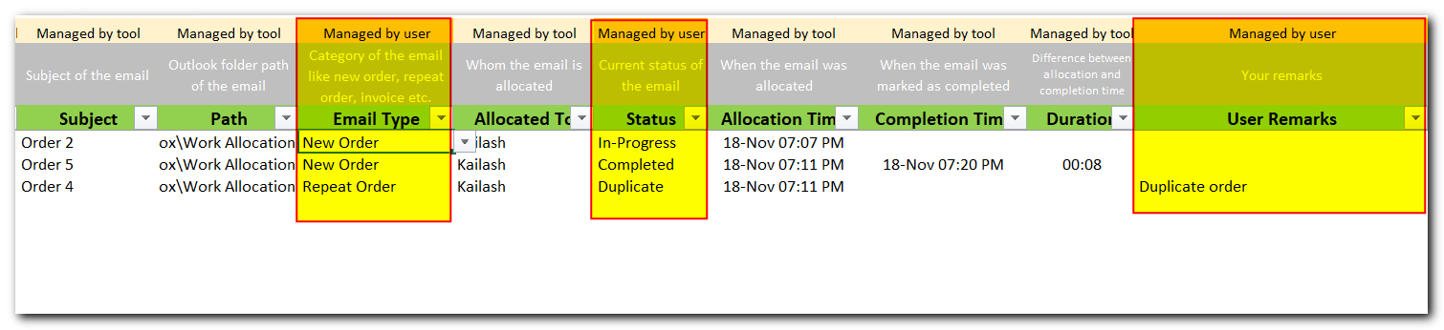
- Users can also use few more options/filters available on top of the sheet. Like viewing recent updates, In-Progress Emails.
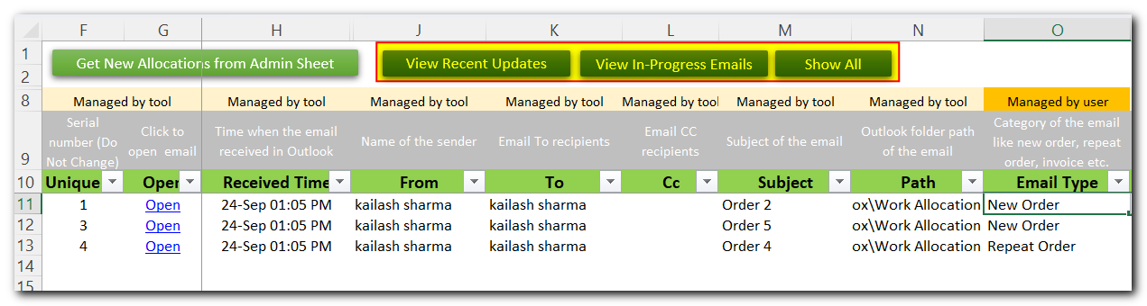
- Let’s go back to login screen and re-login by Admin user.

- When admin users wants latest updates. He/she can click on ‘Get Latest Status from Agent’s Sheets’ button.
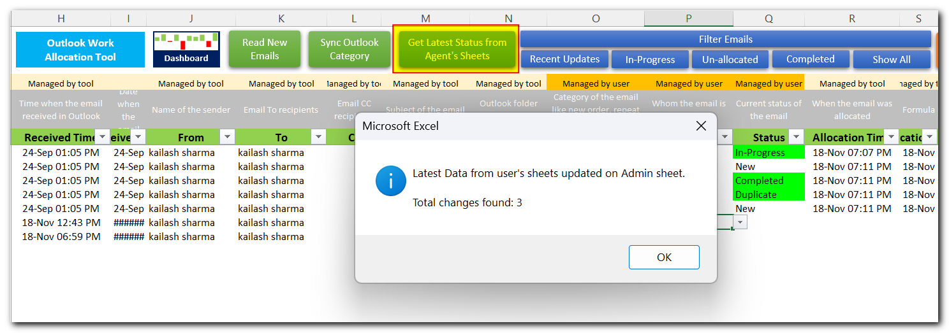
- You can see recent updates highlighted in green color. Also Status History, Completion Time, and Duration will be auto updated by the tool.
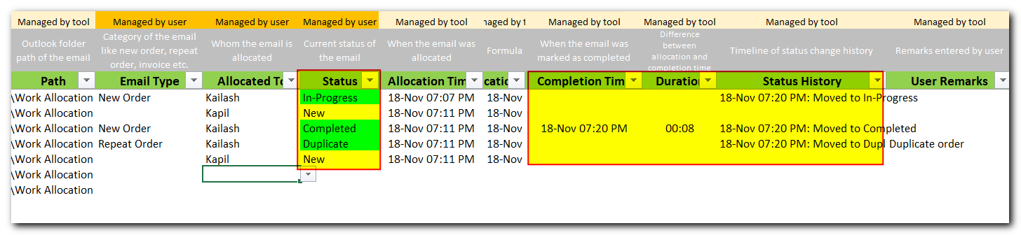
- Let’s see how these transactions appears on dashboard sheet. Dashboard sheet is connected with Admin sheet data and gets auto refreshed. Only Admin user can access Dashboard sheet.
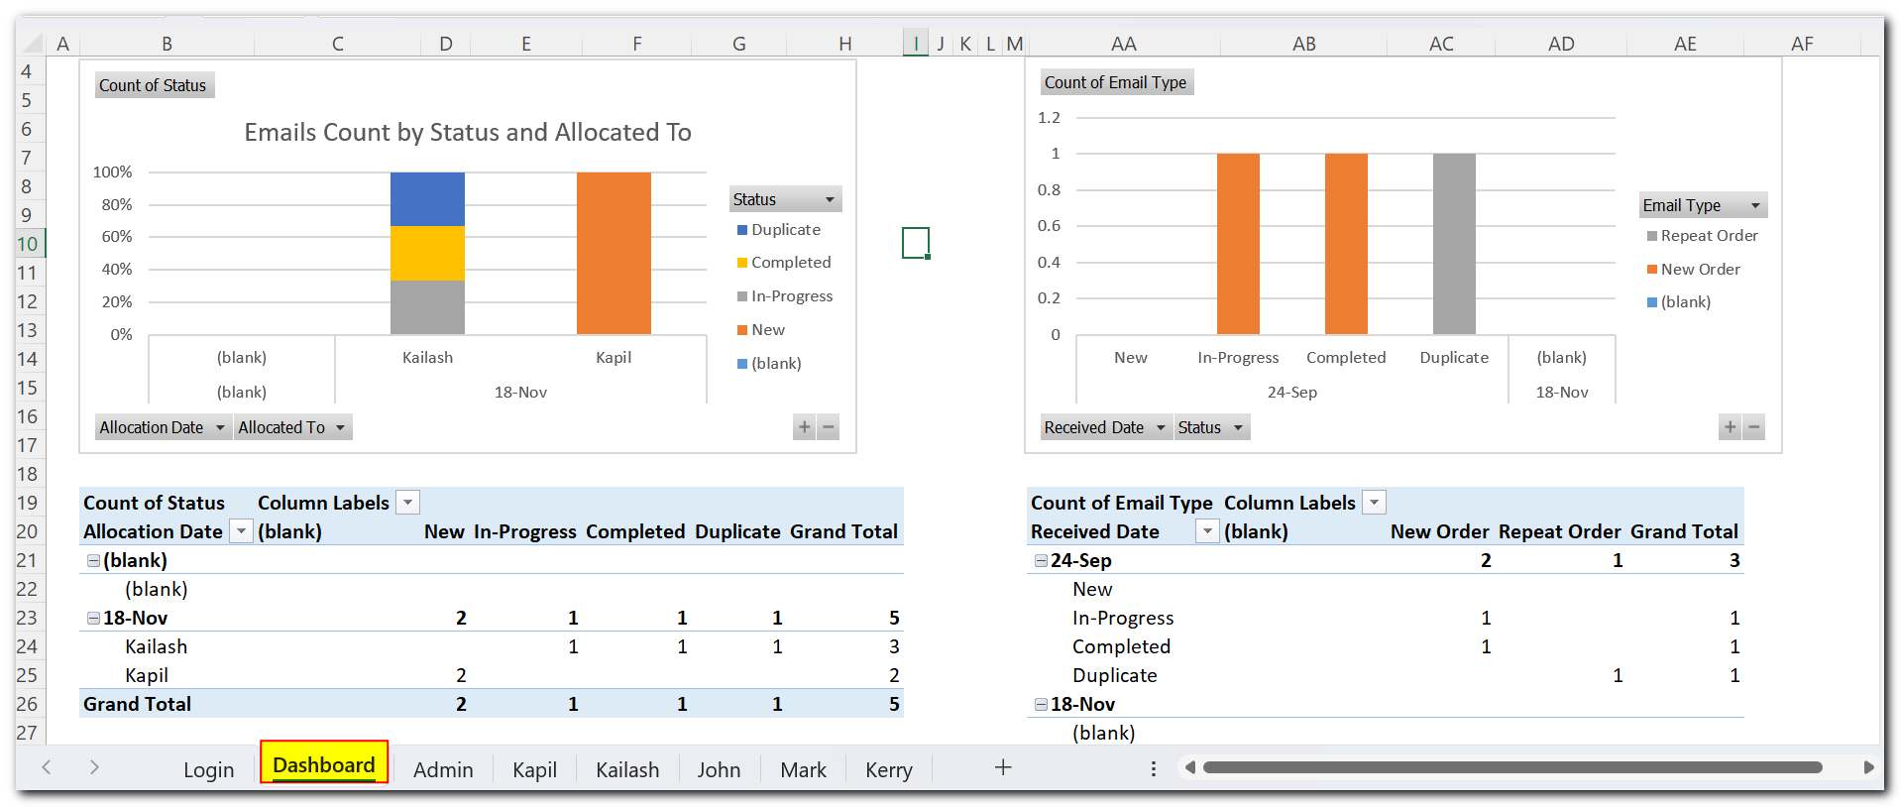
- This completes our user manual. For any further support or clarification, please drop an email to excelsirji@gmail.com. All the very best.

