Work Allocation Tool

Contents
Work Allocation Tool 1
About the tool 2
Tool Features 3
Benefits 7
System Requirements 7
Limitations 7
How to use this tool 8

About the tool

Work Allocation Tool is an Excel based VBA tool which helps to allocate and manage work using Excel Application. The tool can be saved at a common place like SharePoint/OneDrive where multiple users can open the tool at the same time. Tool has inbuild dashboard and configurations to manage it effectively.
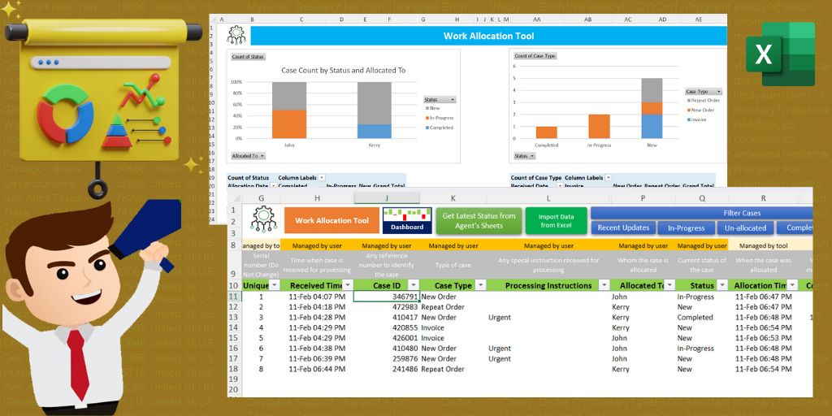

Tool Features

Multiple Configurations: Configure the tool and use it as per your requirements. Configurations available for Admin password, Case Types, Status and User Management.
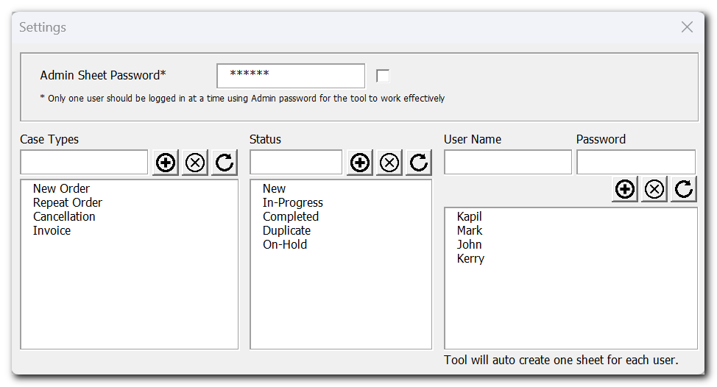

Login Enabled: All users are required to login into the tool to access their respective sheets. This helps to control modifying other user’s data.
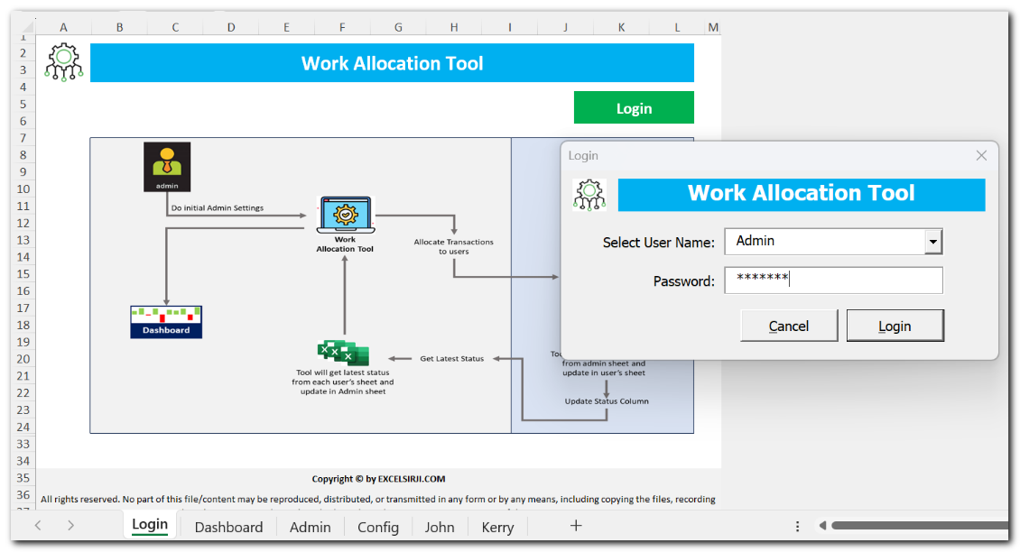

Import from Excel: You can also import transactions or cases from any other Excel file.
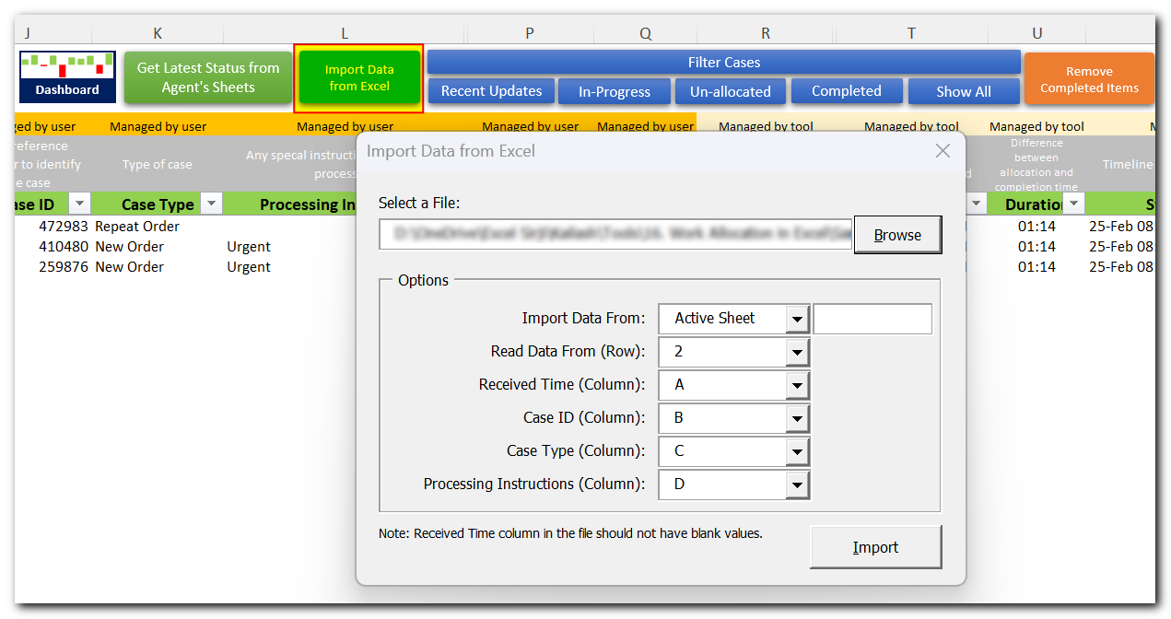
Easily Allocate and Get Latest Status: Allocate cases directly from excel sheet. To get latest status by simply click on a button.
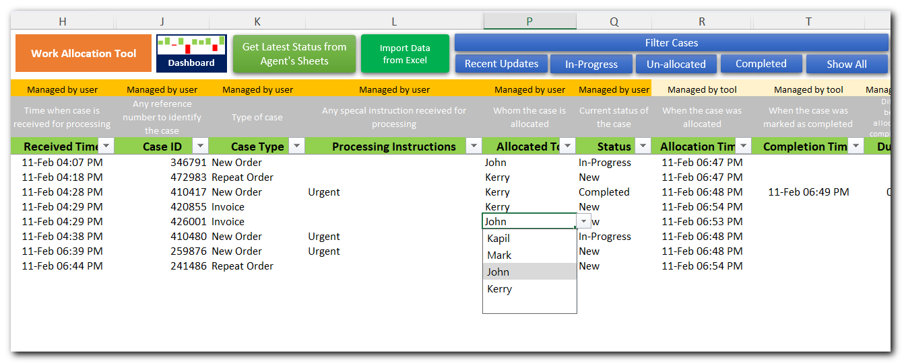
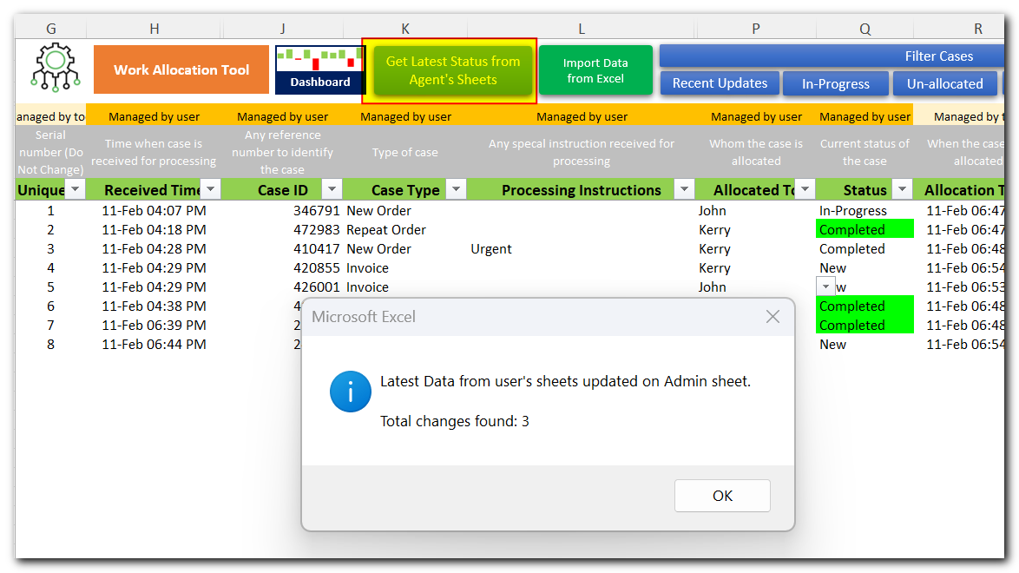
Filter Cases: Use the pre-defined filters to easily identify recent updates, In-Progress, Un-allocated or Completed Cases
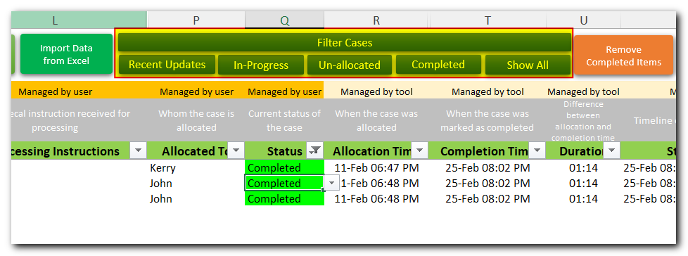

Archive Older Items: Get rid of older items by archiving them to new file and remove from admin sheet.
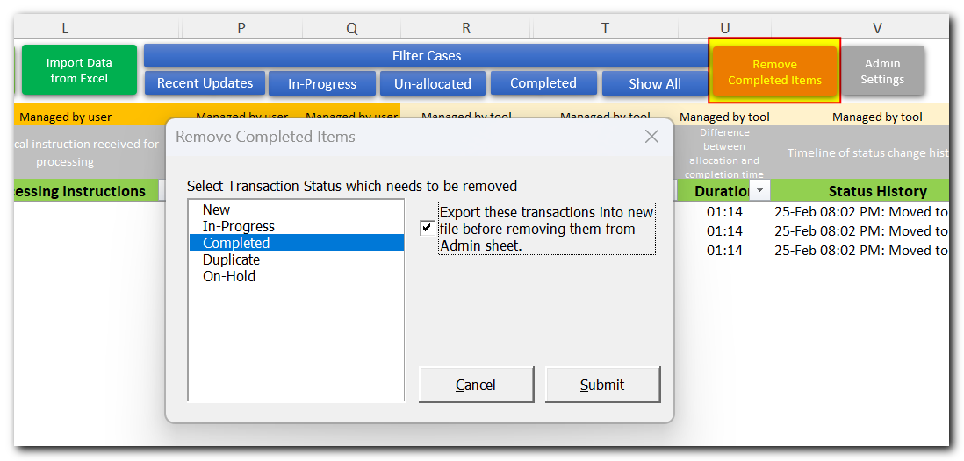

Monitor progress through interactive dashboard: You can monitor progress using pre-defined charts and pivot tables.

Benefits
- Easily and efficiently manage work.
- Get real time processing status along with status history and time taken to process any case.
- Saves huge amount of time, avoid manual consolidation, reporting and monitoring by using centralized tool in place.

System Requirements
- Installed version of MS Excel 2016 or above version
- Windows 10 or above operating system

Limitations
- As the number of records are increased, tool may take more time to complete the task. It is suggested to archive/remove old records to maintain the performance.
- We have tested this tool with 10 users. While tool is compatible to work with more user; however, tool performance might be impacted.

How to use this tool
- You will be receiving your tool copy in zip format.
- Once received, unzip the file, and place it in a SharePoint, OneDrive, Teams or any other shared path where all users can access and open the file at the same time.
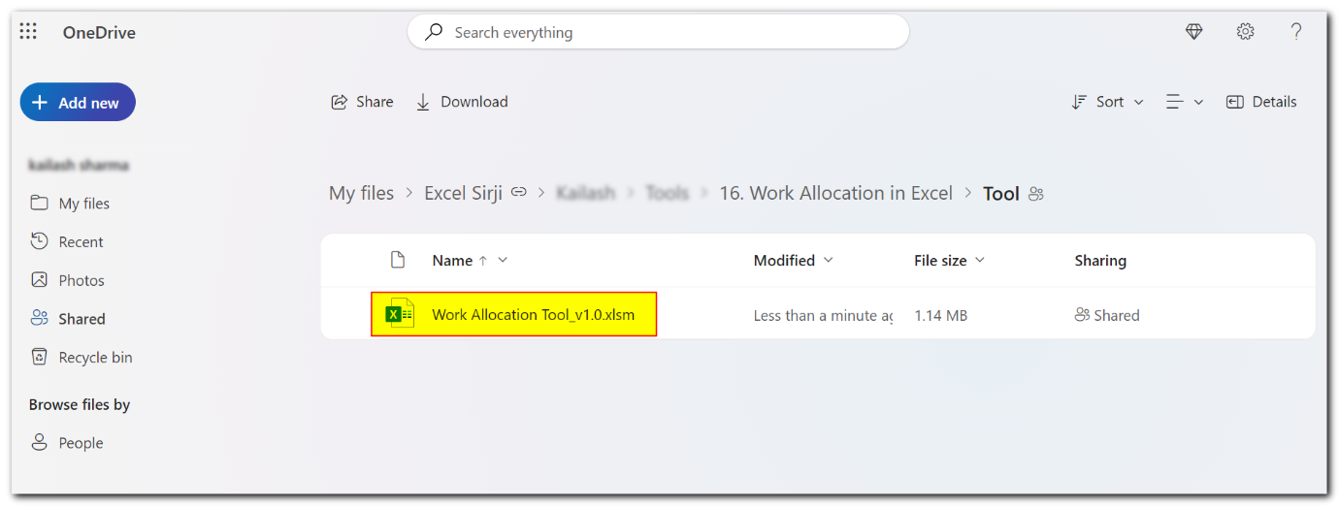
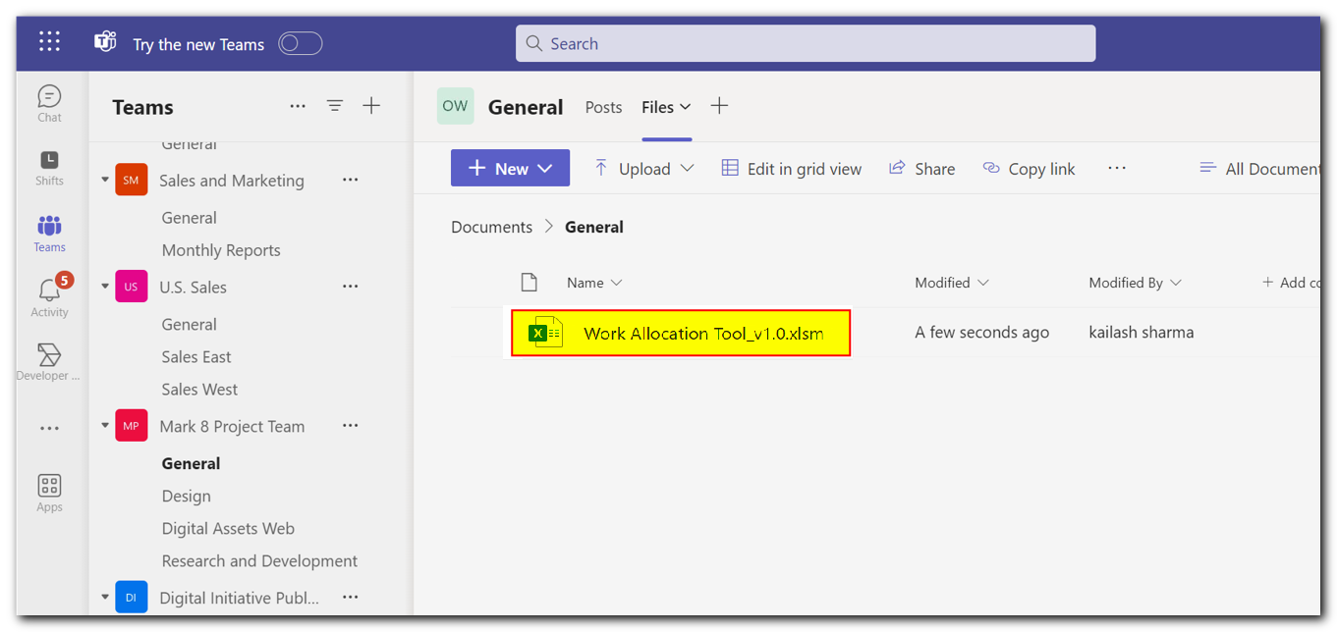
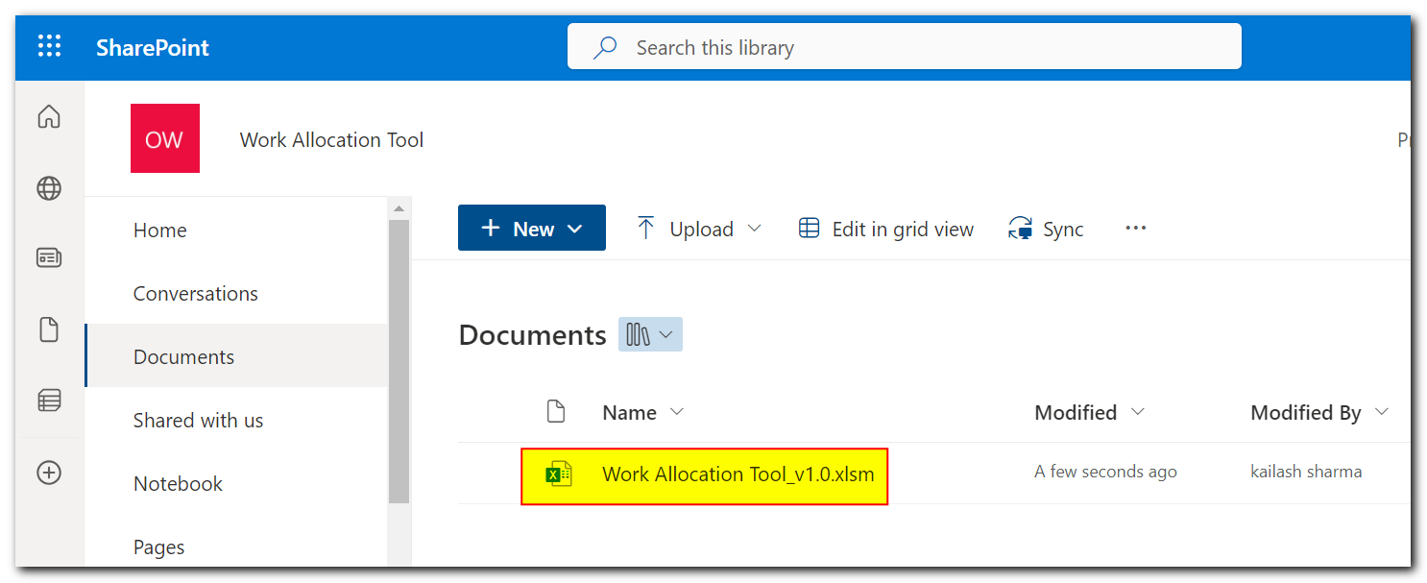

- Open the tool, you will see login sheet. This sheet also contains the process map of how the tool works.
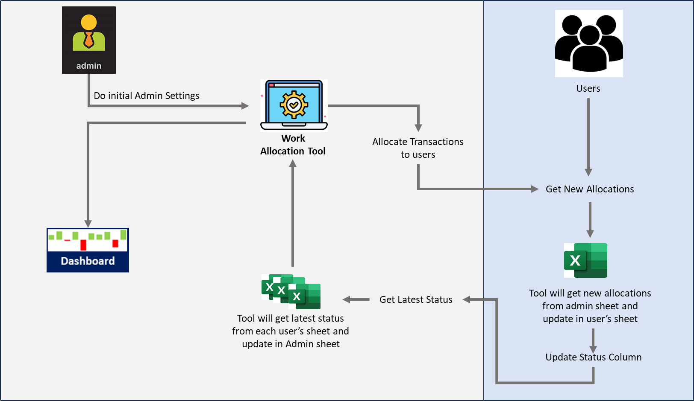
- If you see a yellow bar mentioning macros have been disabled, then click on Enable Content.
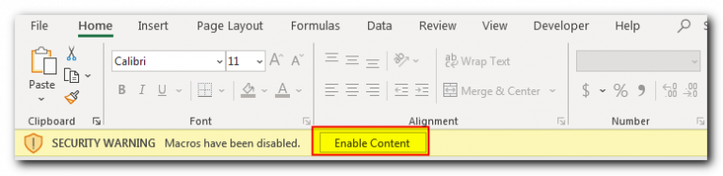
- Use Login button to login using Admin user name. For first time password, refer read me file which much have come in the zip folder.
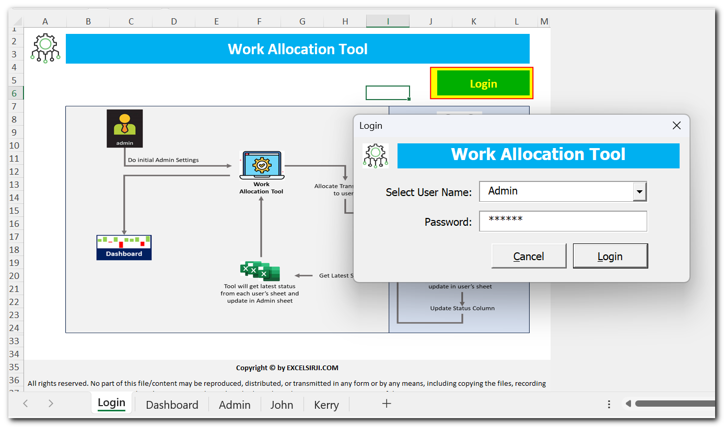
- Once you logged in using Admin id, first thing needs to be done is admin settings. Click on ‘Admin Settings’ button on Admin sheet for the same.
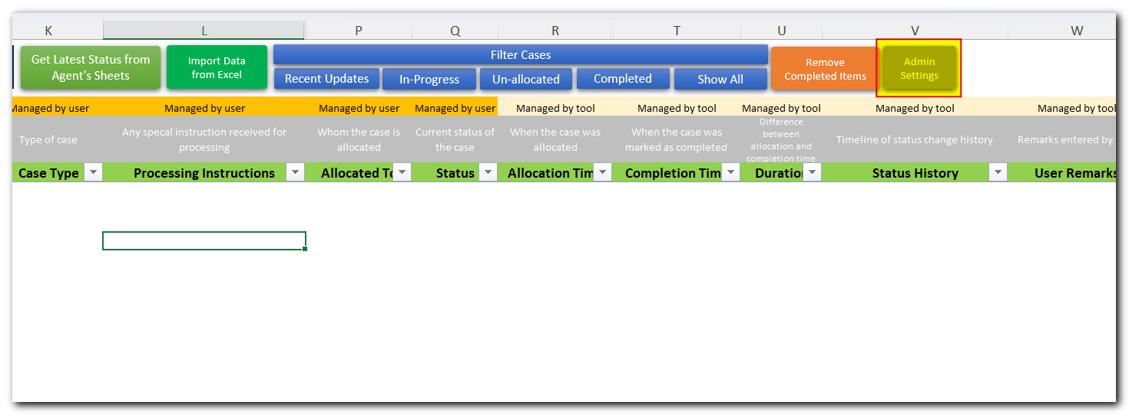
- Let’s understand Admin settings.
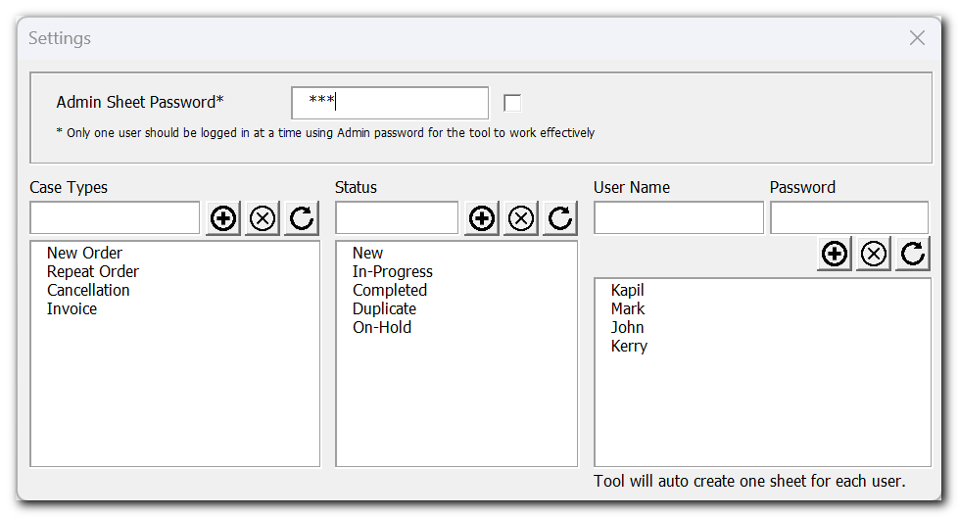
Admin Sheet Password: This is the password used to login using Admin user name.
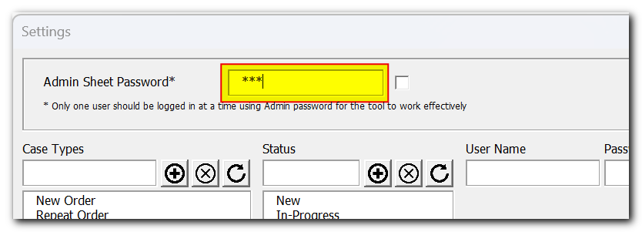
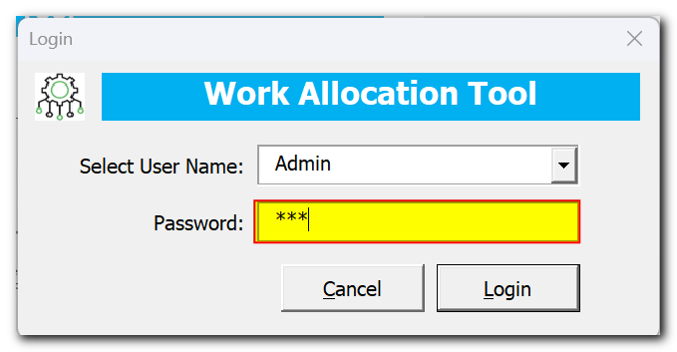
Case Types, Status Settings: Use these settings to control the dropdown appears on the sheet.
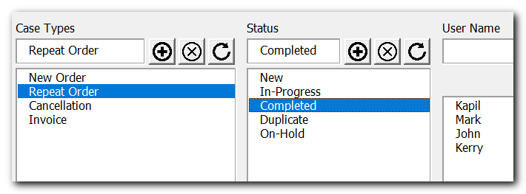
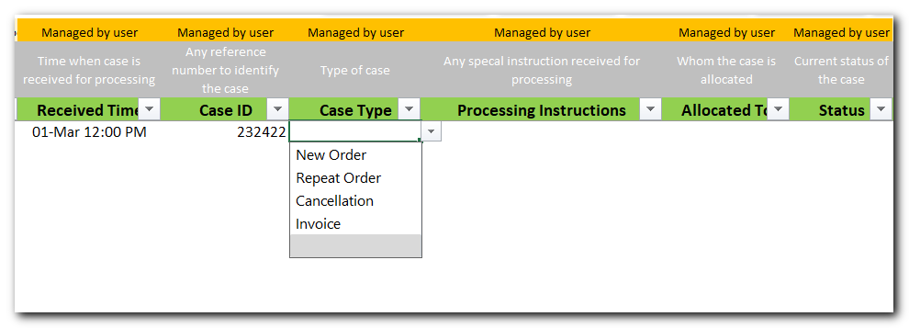
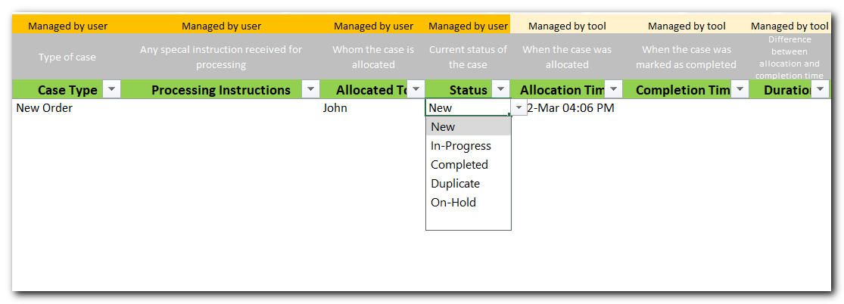
User Management: Use this section to add remove users from the tool. Note that for each user a new sheet with the user name will be created. You can set user’s password so that users will not be able to modify data other than their respective sheet.
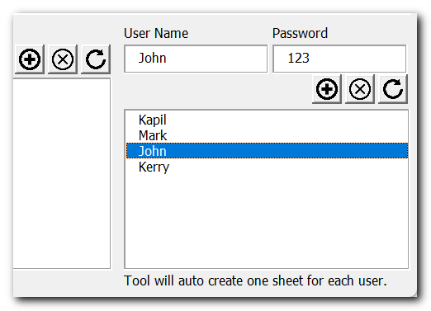
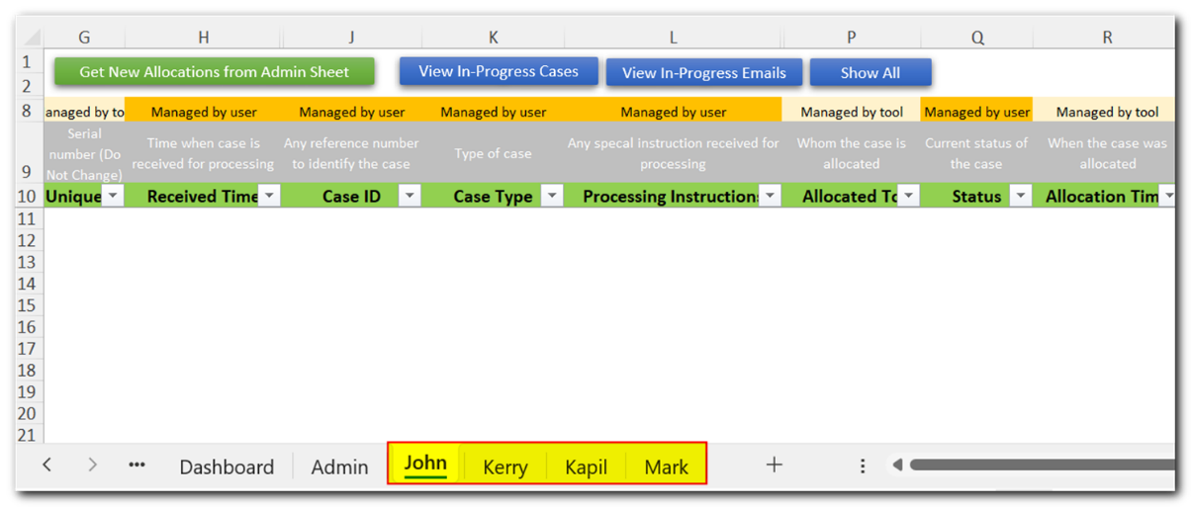
- Once Admin settings are completed, you are ready to allocate cases to users. There are two ways you can allocate cases. 1. Manual, 2. Import from Excel

Manual: To manually allocate cases, enter the details like Received Time, Case ID or Any Reference Number, Case Type, Any Processing Instructions and Allocated To.

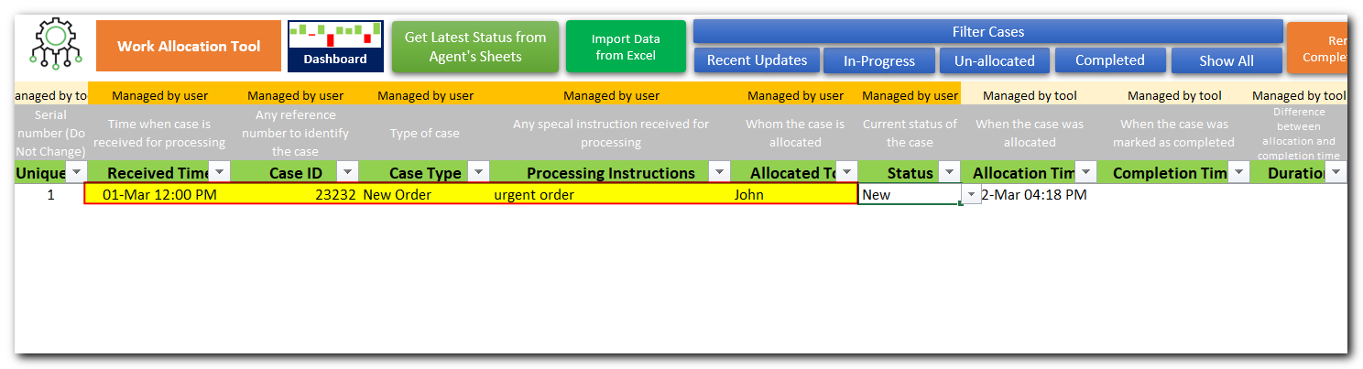
Import from Excel: Second way to import the cases from another Excel file. For that you can click on ‘Import Data from Excel’ button

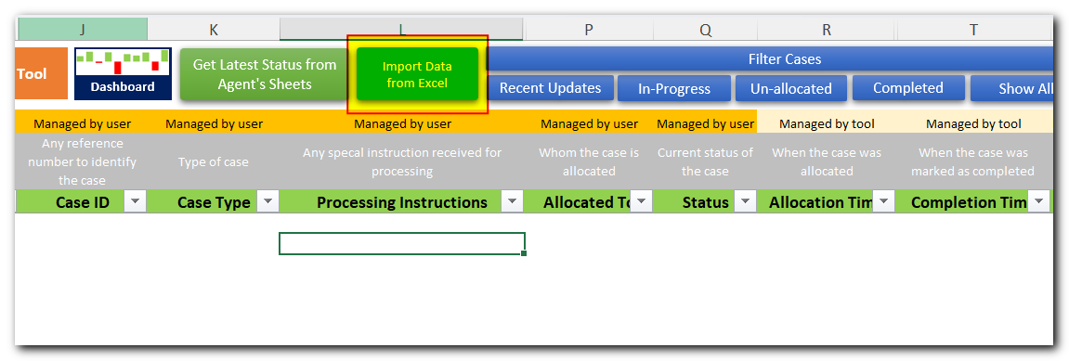

Browse the file you want to import, ensure it has all the required information which is required for import. Below is one of the sample file screenshot.

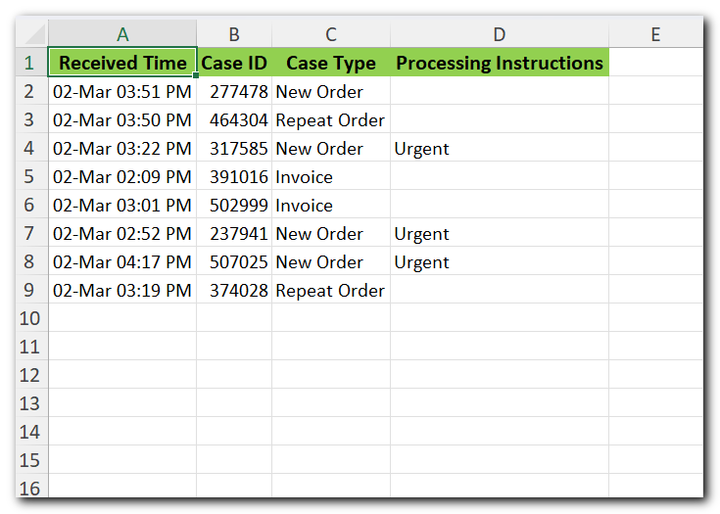
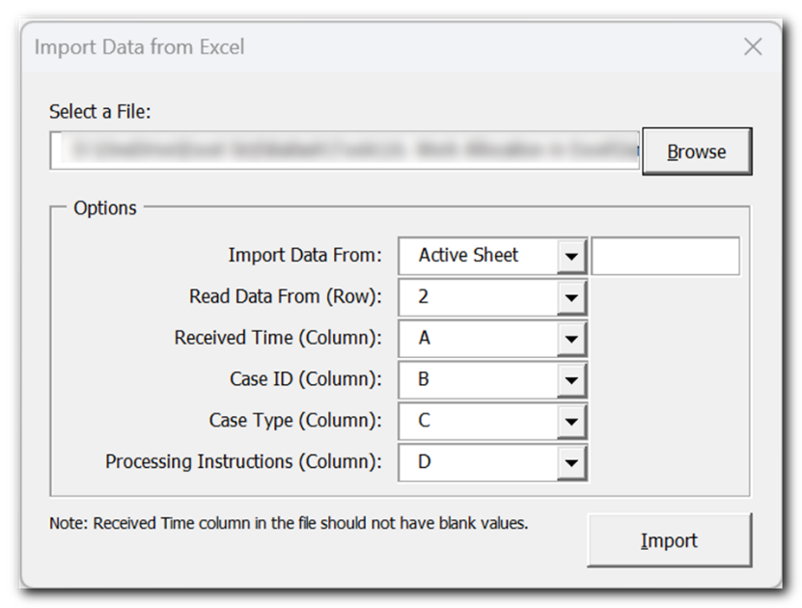
Once the file is imported, you can update ‘Allocated To’ column to allocate the transactions to users.

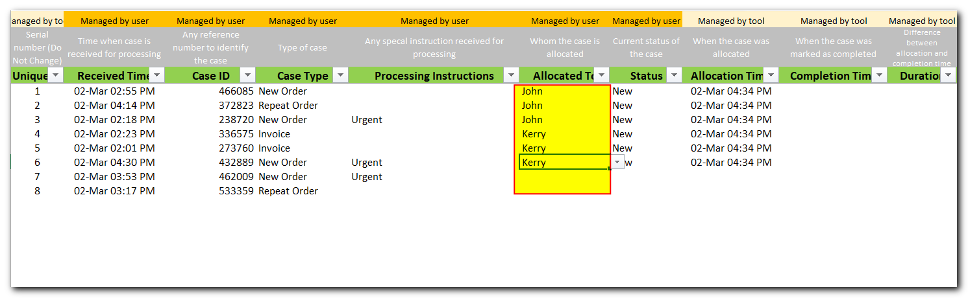

- Now let’s see how a user works on allocated cases. For that let’s login using one of the user.
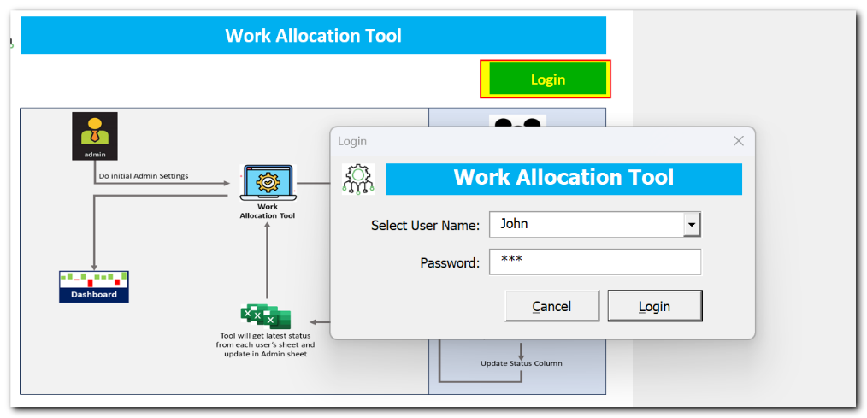
- To view newly allocated cases, let’s click on ‘Get New Allocations from Admin Sheet’
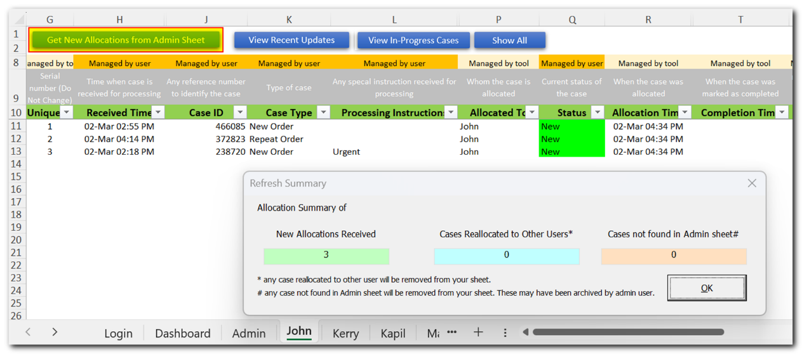
- As the case progresses, Users can update current status of the case in ‘Status’ column and few more columns like ‘Case Type’ and ‘User Remarks’
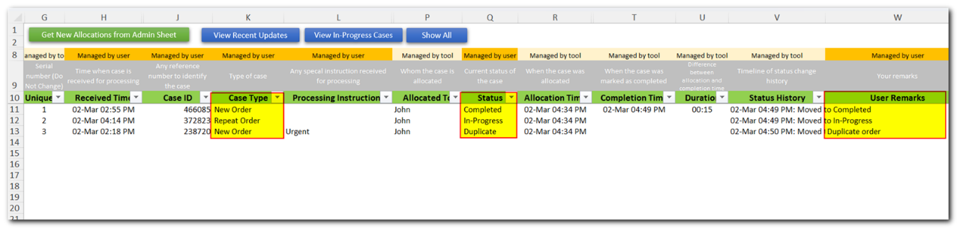

- Users can also use few more options/filters available on top of the sheet. Like viewing recent updates, In-Progress Cases.
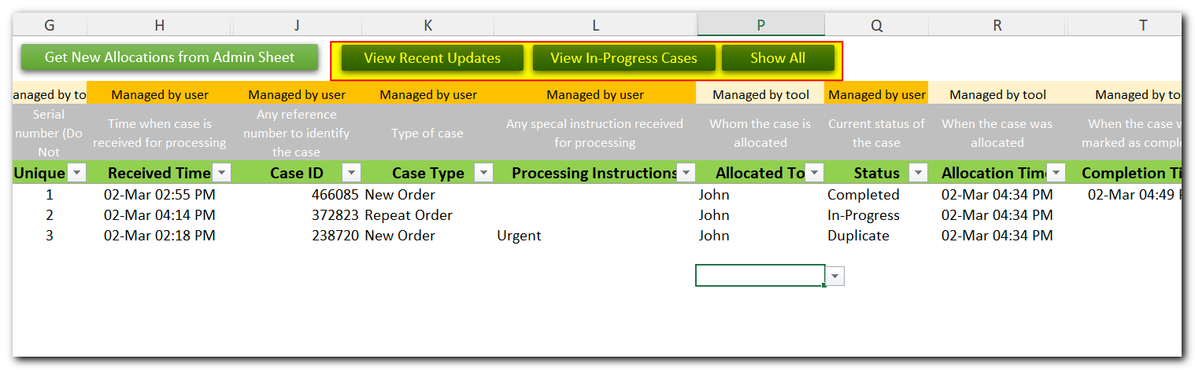
- Let’s go back to login screen and re-login by Admin user.
- When admin user wants latest updates. He/she can click on ‘Get Latest Status from Agent’s Sheets’ button.
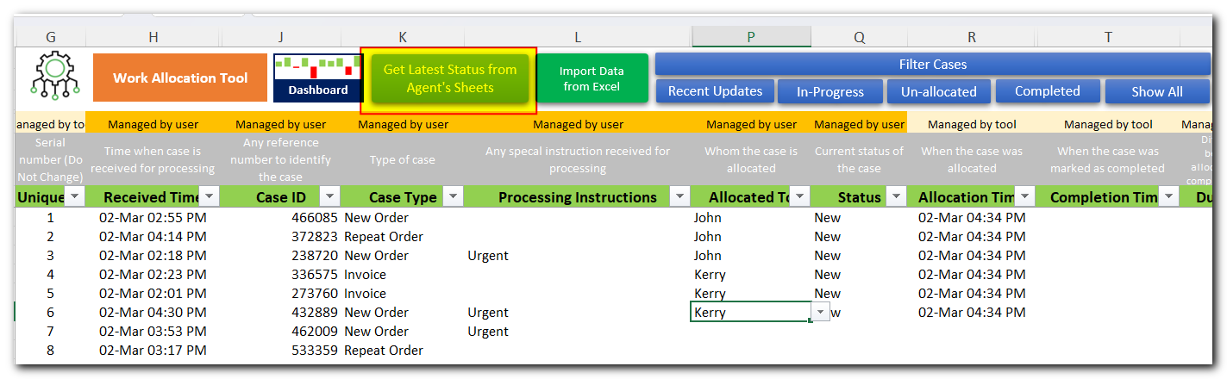
- You can see recent updates highlighted in green color. Also Status History, Completion Time, and Duration will be auto updated by the tool.
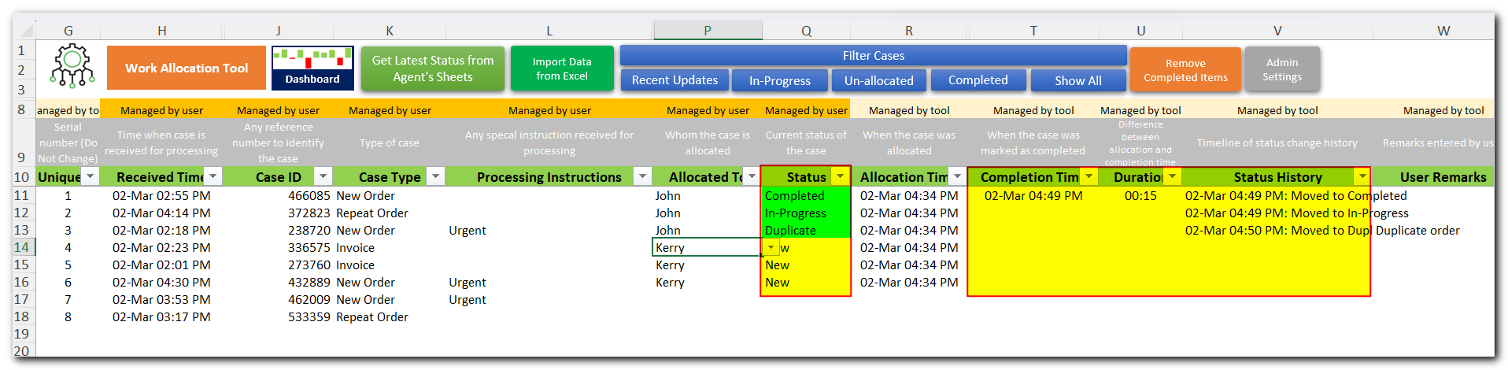
- Let’s see how these transactions appears on dashboard sheet. Dashboard sheet is connected with Admin sheet data and gets auto refreshed. Only Admin user can access Dashboard sheet.
- This completes our user manual. For any further support or clarification, please drop an email to excelsirji@gmail.com. All the very best.

